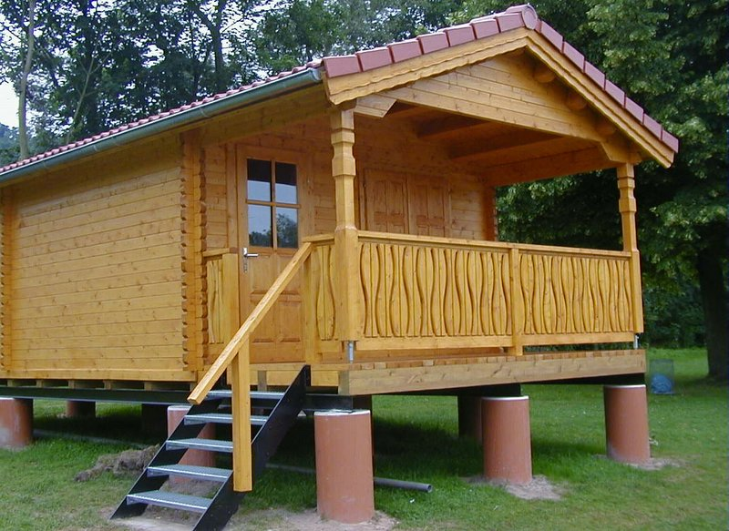 | 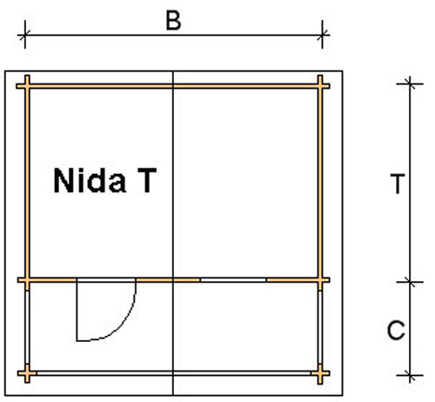
 | 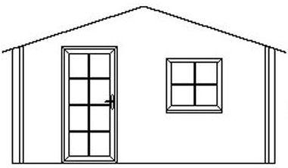

Nida-T Log Cabin
Roof projection: Front 0.70 m
Back 0.20 m
Side 0.30 m

Consists of:
Walls: 45 mm or (60 mm glued) double tongue and groove logs from Northern Pine
Floor: 20 mm tongue and groove floor boards on the impregnated base frame
Roof: 20 mm tongue and groove roof boards on the roof beams
Door: 1 glued cartridge door 90/196 with seal
Windows: 1 double-glazed 80/94 tilt ‘n‘ turn unit

Size (m) |  |  | Price (£) |  | Optional Extras
Cabin |  | Terrace |  |  | Roof Insulation (£) |  | Shingles (£)
B | T | C | 45 | 60 | 45 | 60 | Shingles (£)
3.0 | 3.0 | 1.6 | 2363 | - | 117 | - | 145
3.0 | 4.0 | 1.6 | 2692 | - | 140 | - | 194
4.0 | 3.0 | 1.7 | 2869 | - | 140 | - | 194
4.0 | 4.0 | 1.7 | 3304 | 4068 | 169 | 172 | 238
4.0 | 5.0 | 1.7 | 3632 | 4481 | 191 | 194 | 270
5.0 | 4.0 | 1.7 | 3746 | 4232 | 198 | 200 | 270
5.0 | 5.0 | 1.7 | 4084 | 5114 | 224 | 225 | 295

Optional Extras:

Single window £83
Double window 1200/940 £124
Single door £159
Double door 1700/1970 £267

